PEOPLEADMIN USER’S GUIDE

Sul Ross State University
Alpine, Del Rio, Eagle Pass, and Uvalde Campuses

Revised 10/30/2019

PeopleAdmin, Inc. 816 Congress Avenue
Suite 1800
Austin, TX 78701

TABLE OF CONTENTS
INTRODUCTION 3
GETTING STARTED 4
SYSTEM AND NAVIGATION 5
REQUEST FACULTY, STAFF/EXEC STAFF POSTING (Replacement) 7
NEW FACULTY, STAFF POSITION and POST ACTION (NEW FTE) 8
POSTING OPTIONS…………………………………………………………………………………………………………………………………..9
ADDING SEARCH COMMITTEE TO FACULTY, STAFF POSITIONS 13
MONITORING POSTING PROGRESS 15
POSTING SUMMARY ………….…………………………………………………………………………………………………………………20
HIRING PROCEDURES…………………………………………………………………………………………………………………………….23

INTRODUCTION

Welcome to the Sul Ross State University Online Position Management and Employment Application System. The Human Resources (HR) department has implemented this system to automate many of the paper-driven aspects of the position description and employment application processes.

You will use this system to:
- View Posted Positions according to your specifications
- View applicants to your postings
- Notify HR of your decisions regarding the status of selected applicants

The system is designed to benefit you by facilitating:
- Faster processing of employment information
- Up-to-date access to information regarding all of your Postings
- More detailed screening of Applicants’ qualifications – before they reach the interview stage

The HR department has provided these training materials to assist with your understanding and use of this system.

Security of Applicant Data
To ensure the security of the data provided by applicants, the system will automatically log you out after 60 minutes if it detects no activity. However, anytime you leave your computer we strongly recommend that you save any work in progress and Logout of the system by clicking on the logout link located on the top right next to your current group box.

GETTING STARTED

Important Note:
This guide was prepared using the sandbox test site.

The live site URL for Sul Ross State University is:

Applicant site: https://SRSU.peopleadmin.com
User site:
https://sulross.peopleadmin.com/hr/sessions/new

After navigating to the user site URL, the “login screen” for the system will appear and should be similar to the following screen:

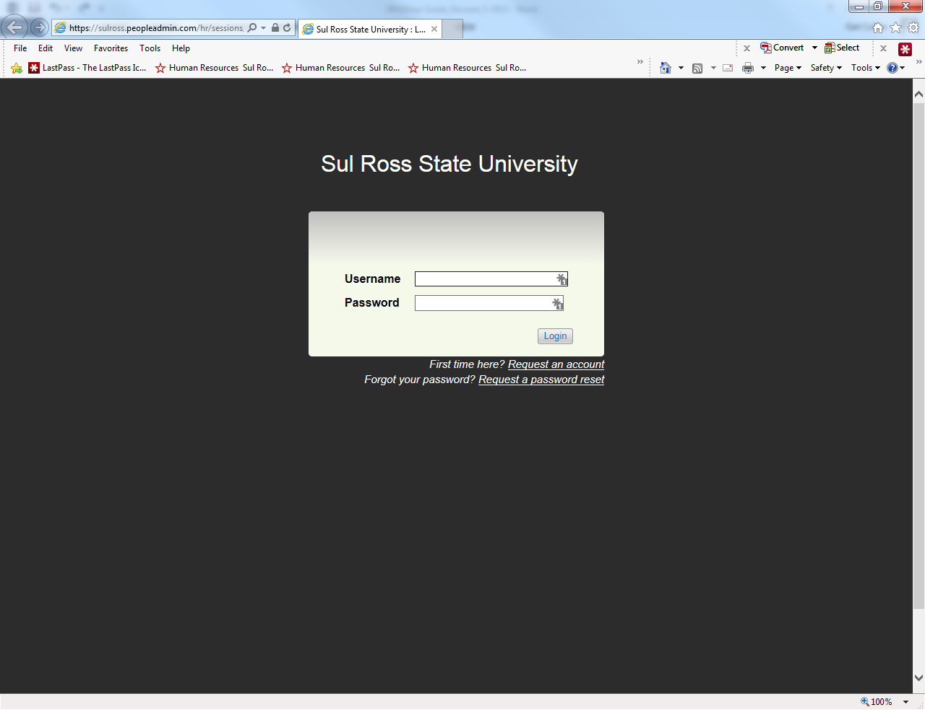

If you have an approved user account, you will be able to log in using your approved User Name and Password, this is unique to people admin, not related to other username and passwords you currently have.

SYSTEM AND NAVIGATION

SYSTEM HELP
At any time, if you have a question, reference the help documentation available in the blue header to the right of your Home Postings Applicants, etc. when you are logged in.

POSITION TYPES
Position Types such as Staff, Faculty, Temporary and Student are the core configuration in PeopleAdmin Release 7.0 that allows for the differentiation in application and posting formats.

WORKFLOWS
Through a number of enhancements to the PeopleAdmin workflow engine, we are able to maintain established workflows. This means one user group, at a time, is able to make edits to or change the status of items in the system (the System Administrator will be able to modify any object in the system at any state).

USER’S ROLE ASSIGNMENT
PeopleAdmin version 7.0 allows you to assign specific organizational units for each user role assigned to a user in the system. For example, through a single user account a user could be assigned to the Department of Biology as a Department Head with Department scope and also as a Search Committee Member with applicant viewing only in a different department. In this example, when the user is logged in to their Search Committee role they will only see postings on which they are assigned as Search Committee member in that department. In addition, when they are in their Department Head role they will have access to all postings in the Biology Department. At no time will they be able to see all postings in in all Departments - only those with their name on it and only when they are in their assigned role.

SRSU Users
Below you will find an overview of SRSU user types, including their level of scope and actions they can take in the system. This information is also contained in the top right corner of each page of the workflow document.

Personal Scope Users: these users must be tied to a posting by name. Manager/Designee

Department Scope Users: these users have Department Scope, and see all of the postings/ applicants within their department or departments.
-Department Authority
-College Authority
-Contracts & Grants

Division Scope Users: these users have Division Scope, and see all of the postings/ applicants within their division(s)
-Division Authority

University Scope Users: these users have University Scope, and basically have overview of all postings/applicants across the entire system.
-VP Finance & Operations
-President
-Human Resources

The Home Page

This is the page you see when you log in. It presents a dashboard that provides access to:

  - Announcements - these may be information-only or alerts.
  - Items that need your attention - summary views of your inbox and Watch List are available on the home page.

  - Links to pages and saved searches that you use often.

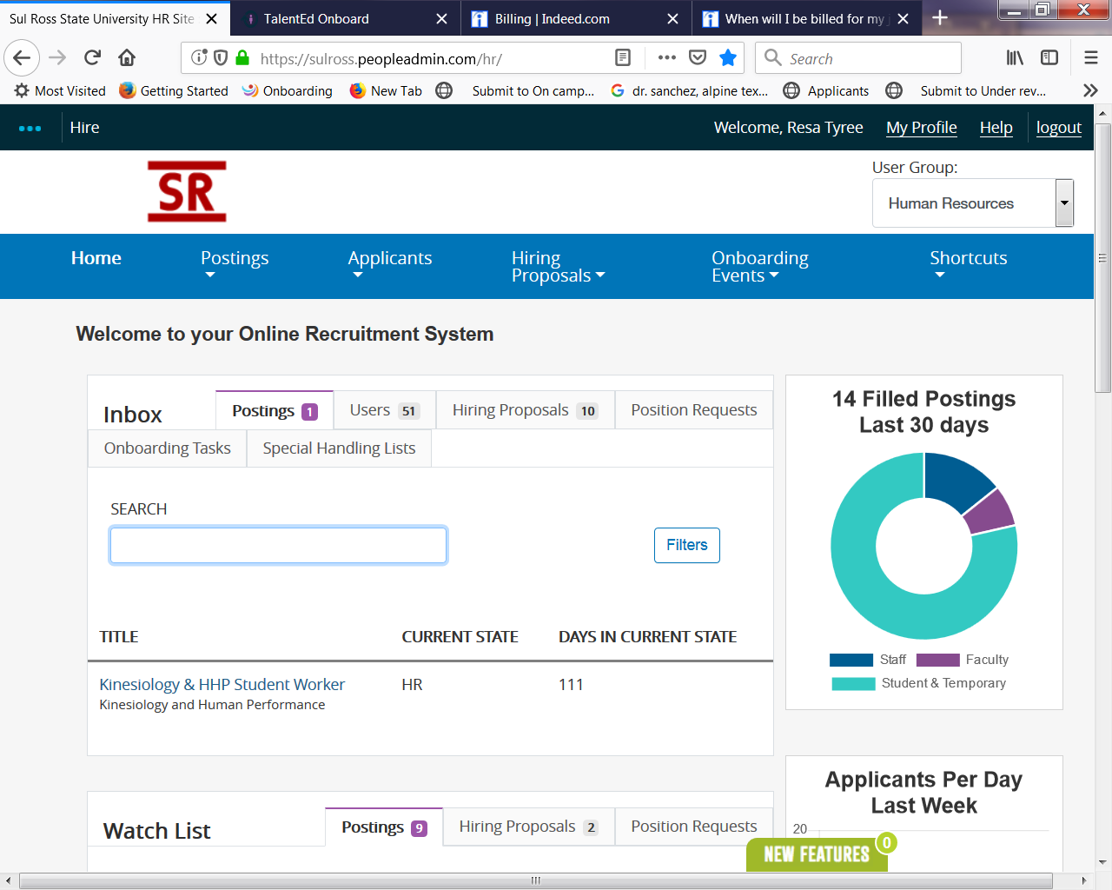
Features on All Pages
Some items are available anywhere in your site. Others are only available in certain areas or to people with certain permissions on the site. No matter where you are in the site, the following items are always available:

  - Header - logo and other graphics, your login information, shown by your name in the drop down box, the title showing will be reflected to what accesses you have
  - Navigation bar - tabs that provide access to the main areas of the user interface.
  - Footer - the information that may be placed at the bottom of the page.
  - Work area - the portion of the screen that presents controls for different tasks, and differs from page to page.

INBOX
This will probably be one of the most useful tools for you in the system. For each individual user, the Inbox will always contain all items in the system that require that user’s attention, across all user roles they may possess. When in doubt check your inbox.

WATCHLIST
You will notice that everywhere you see postings in the site you will have the ability to “Watch” an item by clicking on the binoculars icon.

What to Do When You Don't See the Tab You Need

The HR Suite is organized in three modules. A highlighted area in the header, near the links for your inbox and watch list, presents the name of the module in which you are working. Most of the time you will be in the Applicant Tracking Module to view postings, applicants, and move applicants through the workflow. The 3 modules are:

- ADMIN - Site setup tasks, site and profile administration tasks.

- APPLICANT TRACKING - Postings, titles, pools, applicants, hiring proposals, users.
- POSITION MANAGEMENT - Position descriptions, titles, hiring proposals, users.

Your system privileges determine the modules you can access and the tabs available to you in each module.

How Pages Are Organized

Most tabs provide access to lists of similar items - for example, postings, supplemental questions, or applicants. Some kinds of information are organized by position type. On the tabs where you access these kinds of information, you must select the appropriate position type from the tab menu.

On pages that present lists of similar items, typically these things are true:

  - A check box is associated with each item to allow you to select more than one at a time for bulk operations.
  - An Actions control on the list page presents a menu of bulk operations and general actions.
  - The name of each item in the list is a link that opens the summary view.
  - A Take Action control on each item's summary page presents a menu of actions you can take on the item.

REQUEST FACULTY, STAFF/EXEC STAFF POSTING (Replacement)
The Request Posting (Replacement) action is used when you plan to replace and existing FTE with a new hire. Typically, no changes are made to the Job Description, simply replacing a terminated/separated/retired employee.

NEW FACULTY, STAFF POSITION and POST ACTION (NEW FTE)

GETTING STARTED

All Non Budgeted staff and faculty positions require a Personnel Requisition form signed and approved by Dept head, Budget Department, Dean, Vice President, and a final approval by the Executive Cabinet to fill positions.
All Budgeted positions you need Dept head, Budget Department, Dean, Vice President approval.
Student positions require the Personnel Requisition approved by Dept head & Budget Department . Once the position is approved to post, Human Resources or Career Services will post the Faculty/Staff /Student/Temporary position. The Requesting Department will need to make sure Human Resources / Career Services has the posting detailed information (job description) for the posting.

Human Resources can specify specific document(s) you require for your posting using the new PeopleAdmin website. Please notify Human resources of the documents required, optional or not used example seen below:
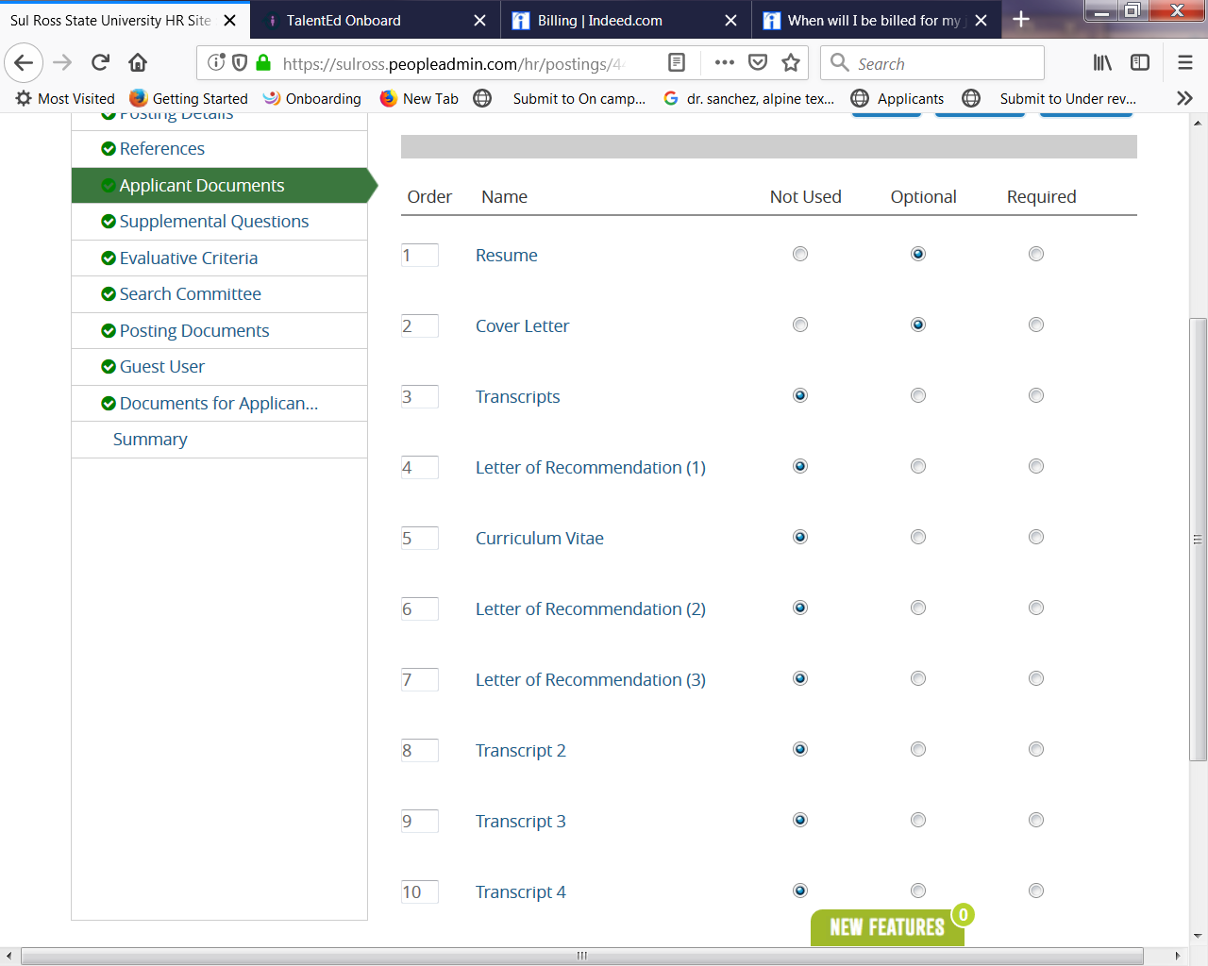

APPLICANT DOCUMENTS
- Here are some details on working with Applicant Documents:
- Required documents: You can specify documents you require to be uploaded to the applications, (ie: resume, cover letter, curriculum vitae…..) the application cannot be submitted without these required documents uploaded.

- Optional Documents: Allow applicants to upload documents to the application but if they choose not to attach them they can still submit the application.

- Notify Human Resources how you would like the documents ordered.

POSTING OPTION Supplemental Questions:

Adding a Question:
  - If you would like to add supplemental questions, posting a question is now an option. Notify Human Resources if you would like an extra layer of screening by adding a supplemental question:

      - Submit to Human Resources a Question and Possible Answers
        - Selecting Open Ended Answers to give applicants a free-text field for answering the question.
        - Selecting Predefined Answers will prompt a menu of possible answers. The default is two answer choices, there is no limit.

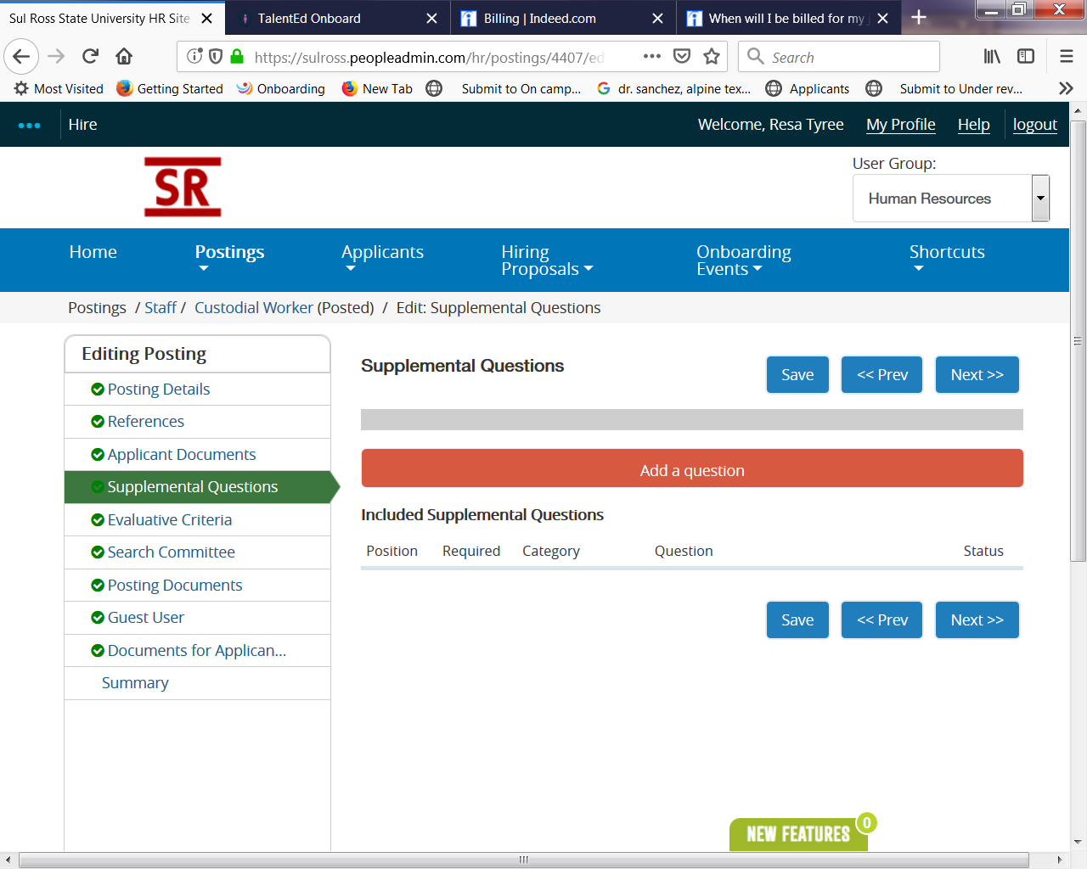

Supplemental Question Options:
Position – Allows you to reorder questions
Required? – Makes the question Required on the Action
Category - Shows the name selected from the Category dropdown menu
Question: Shows the selected question
Status – Shows the approval status of the question
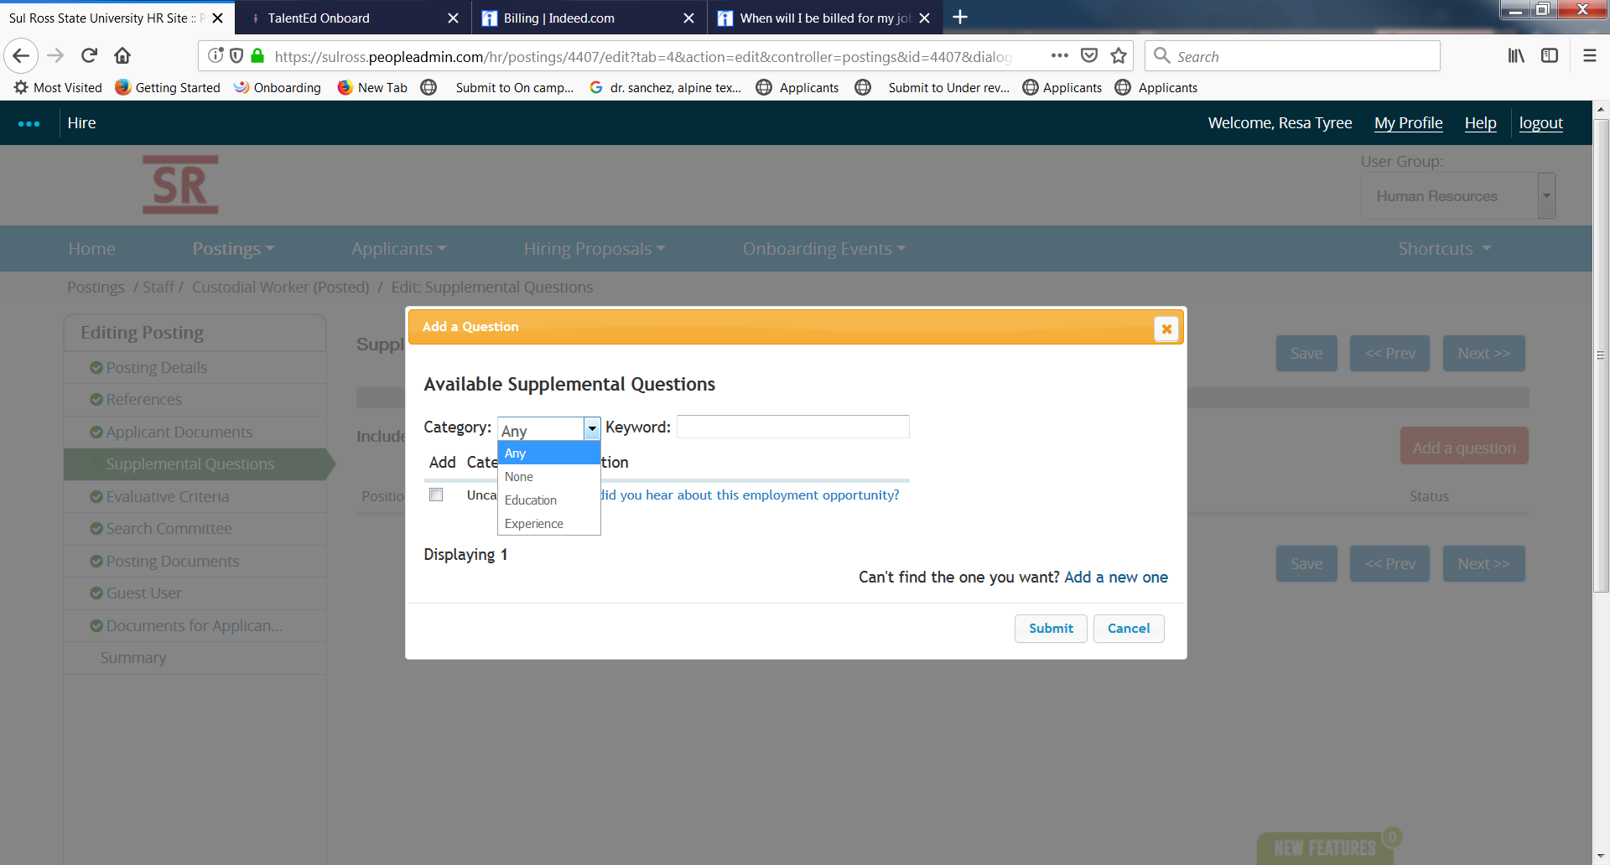

    - Possible Answers: Will show whether applicant answer options are Predefined or Open Ended.
      - For questions with Predefined Options, the system can assign points or mark an answer choice as a disqualifier to a question referencing education or experience.

- If would like to add a supplemental question to your posting, please contact Human Resources and they will get it added to your posting.

Evaluative Criteria

Evaluative Criteria is used to rank or give weight to a selected portion of the applicant work history, education or experience, etc. Notify Human Resources of any Criteria you would like utilized on the posting as a criteria Supplemental Questions

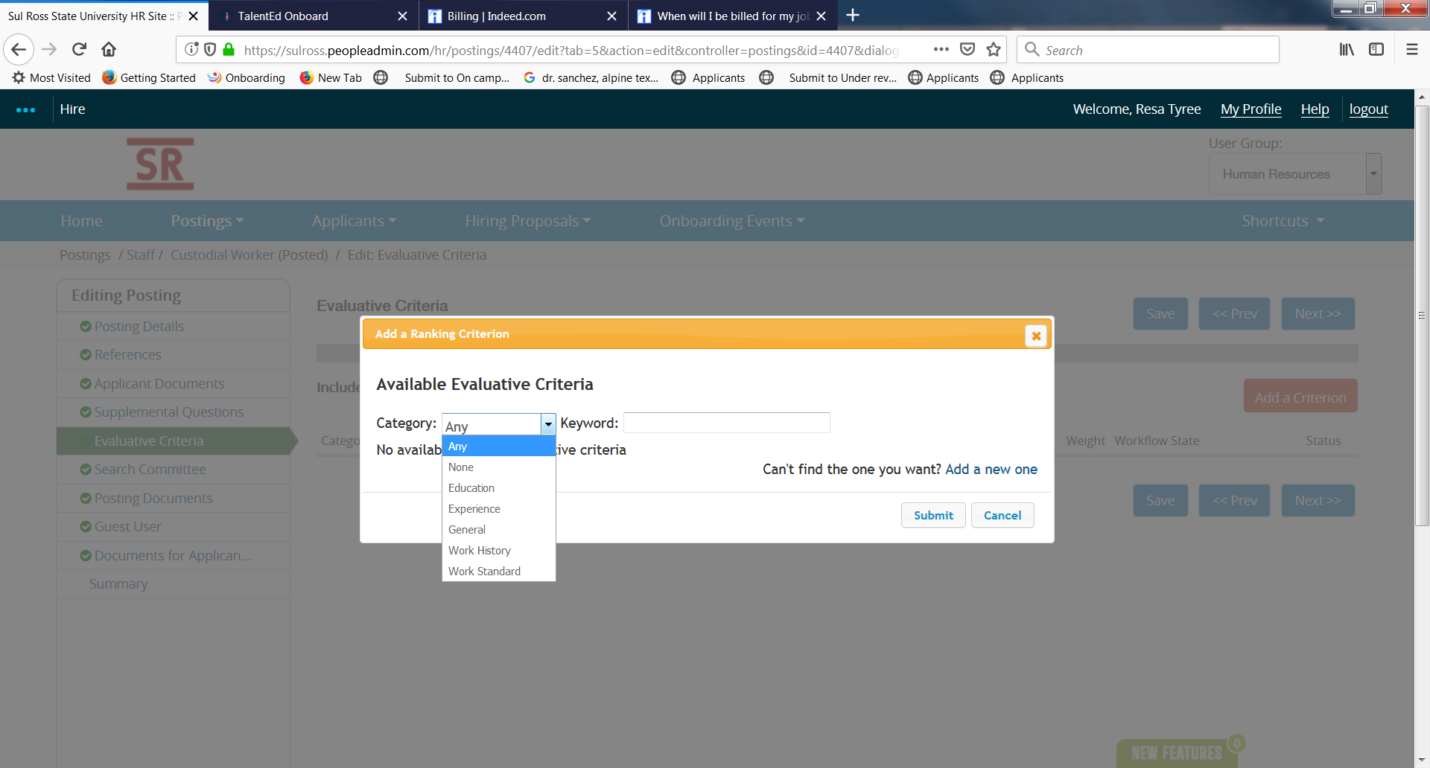

Adding Search Committee to FACULTY & STAFF POSITIONS

Search Committee

- Search Committee screen (see below) allows the “posting creator” to set-up search committee members to view-only access to the posting.

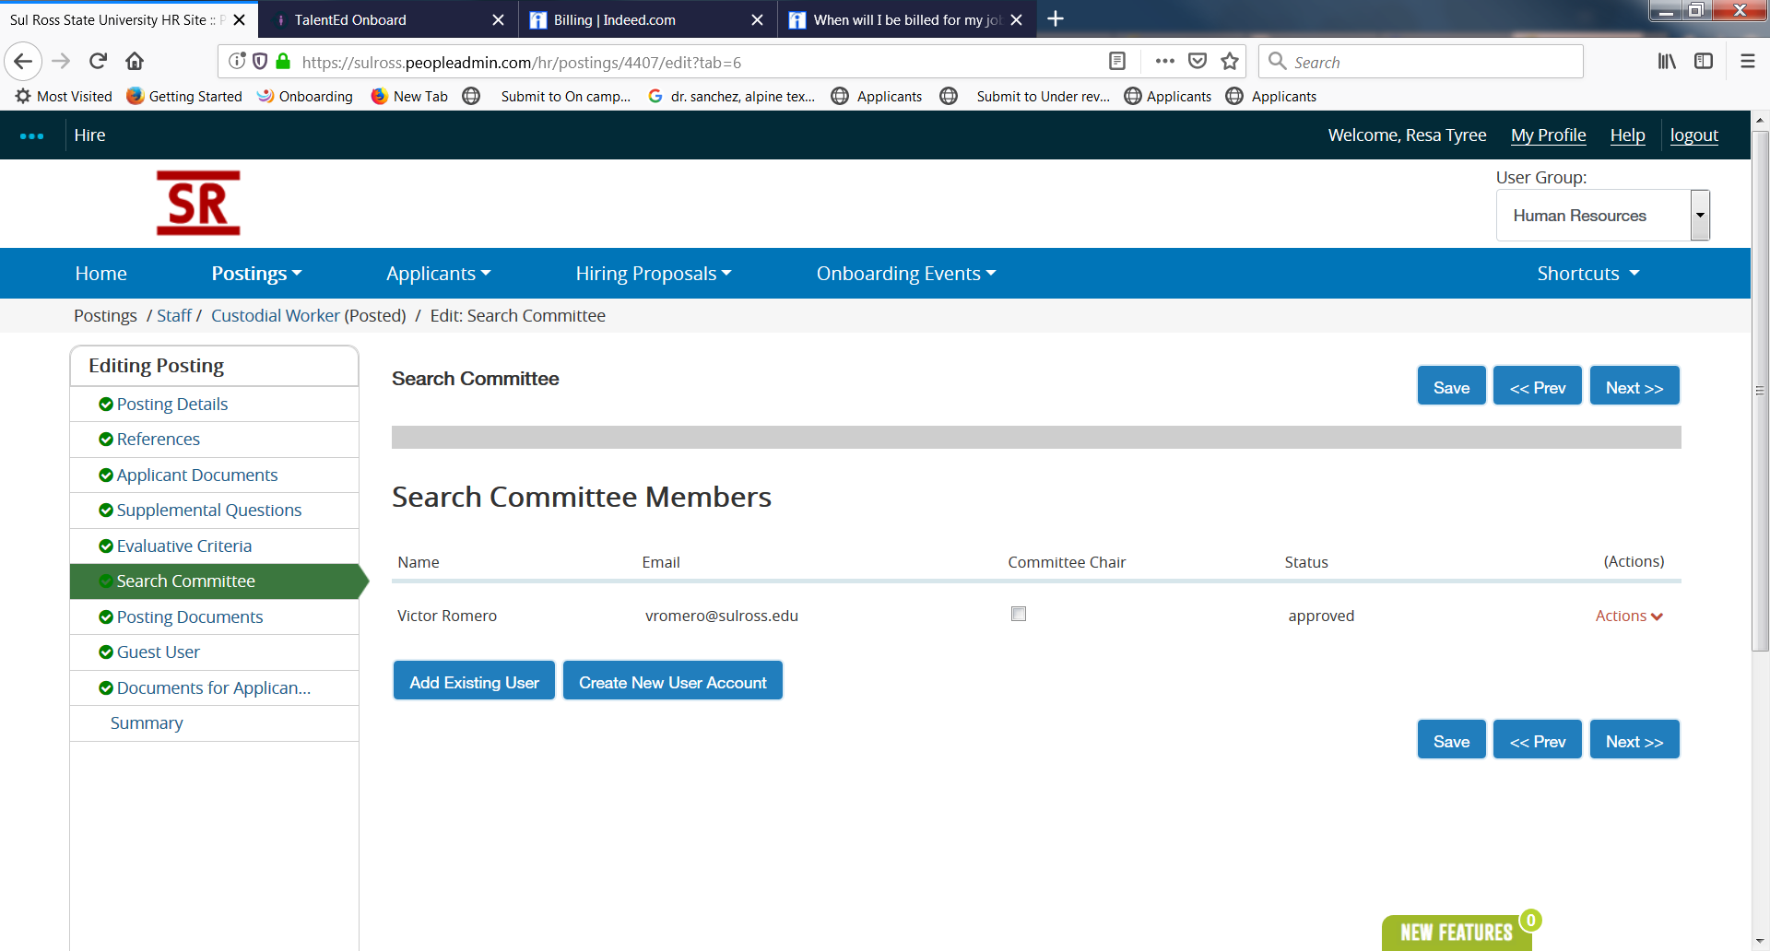

- Contact Human Resources with the following information of the person you want to be on the search committee:

- First Name
- Last Name
- Email
- Username

- NOTE: Search Committee Members are assigned per posting. Meaning, if an employee is selected as a Search Committee Member to three separate postings, the employee will be required to be linked or assigned to each of the three postings individually.

Guest User

- Guest User screen (see below) allows the “posting creator” to set-up Guest Users who may not be employed by Sul Ross to view-only access to the posting. You will provide the Guest User’s name and email address to Human Resources, see screen below:

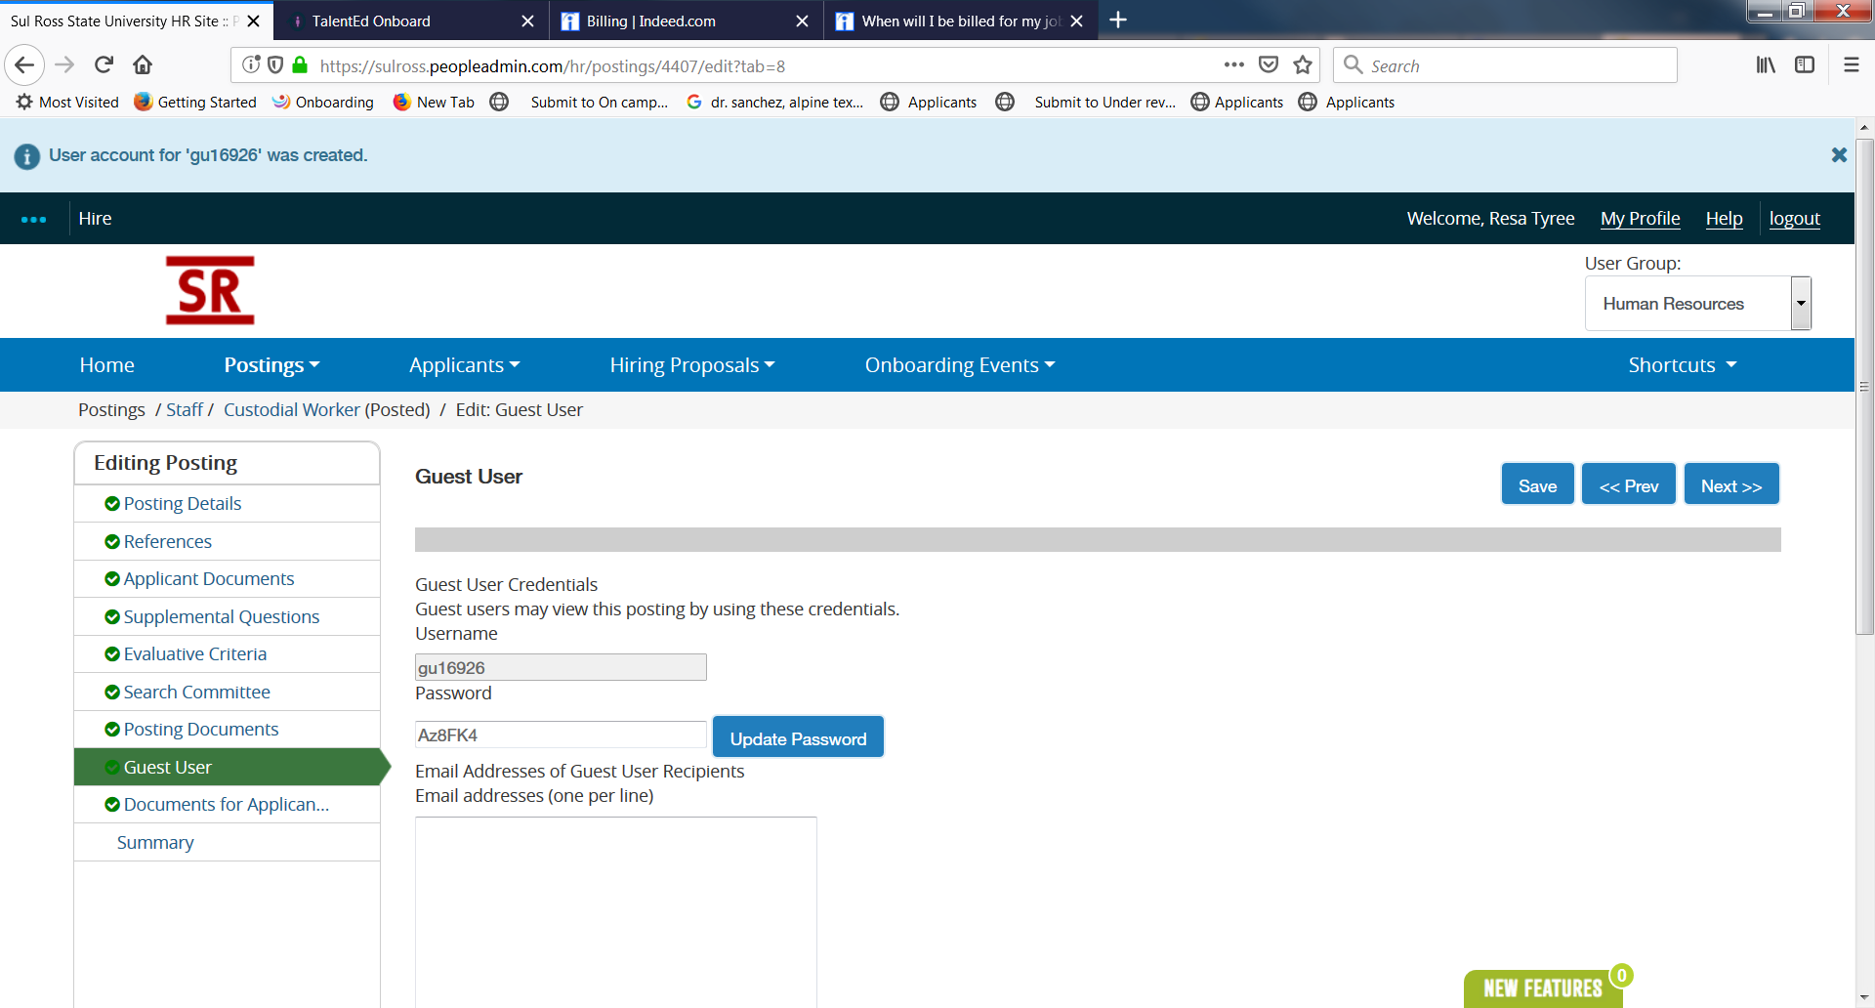

MONITORING POSTING PROGRESS

You are able to monitor the progress of your postings and others you are permitted access.
- Click HISTORY tab on the selected posting (see below)

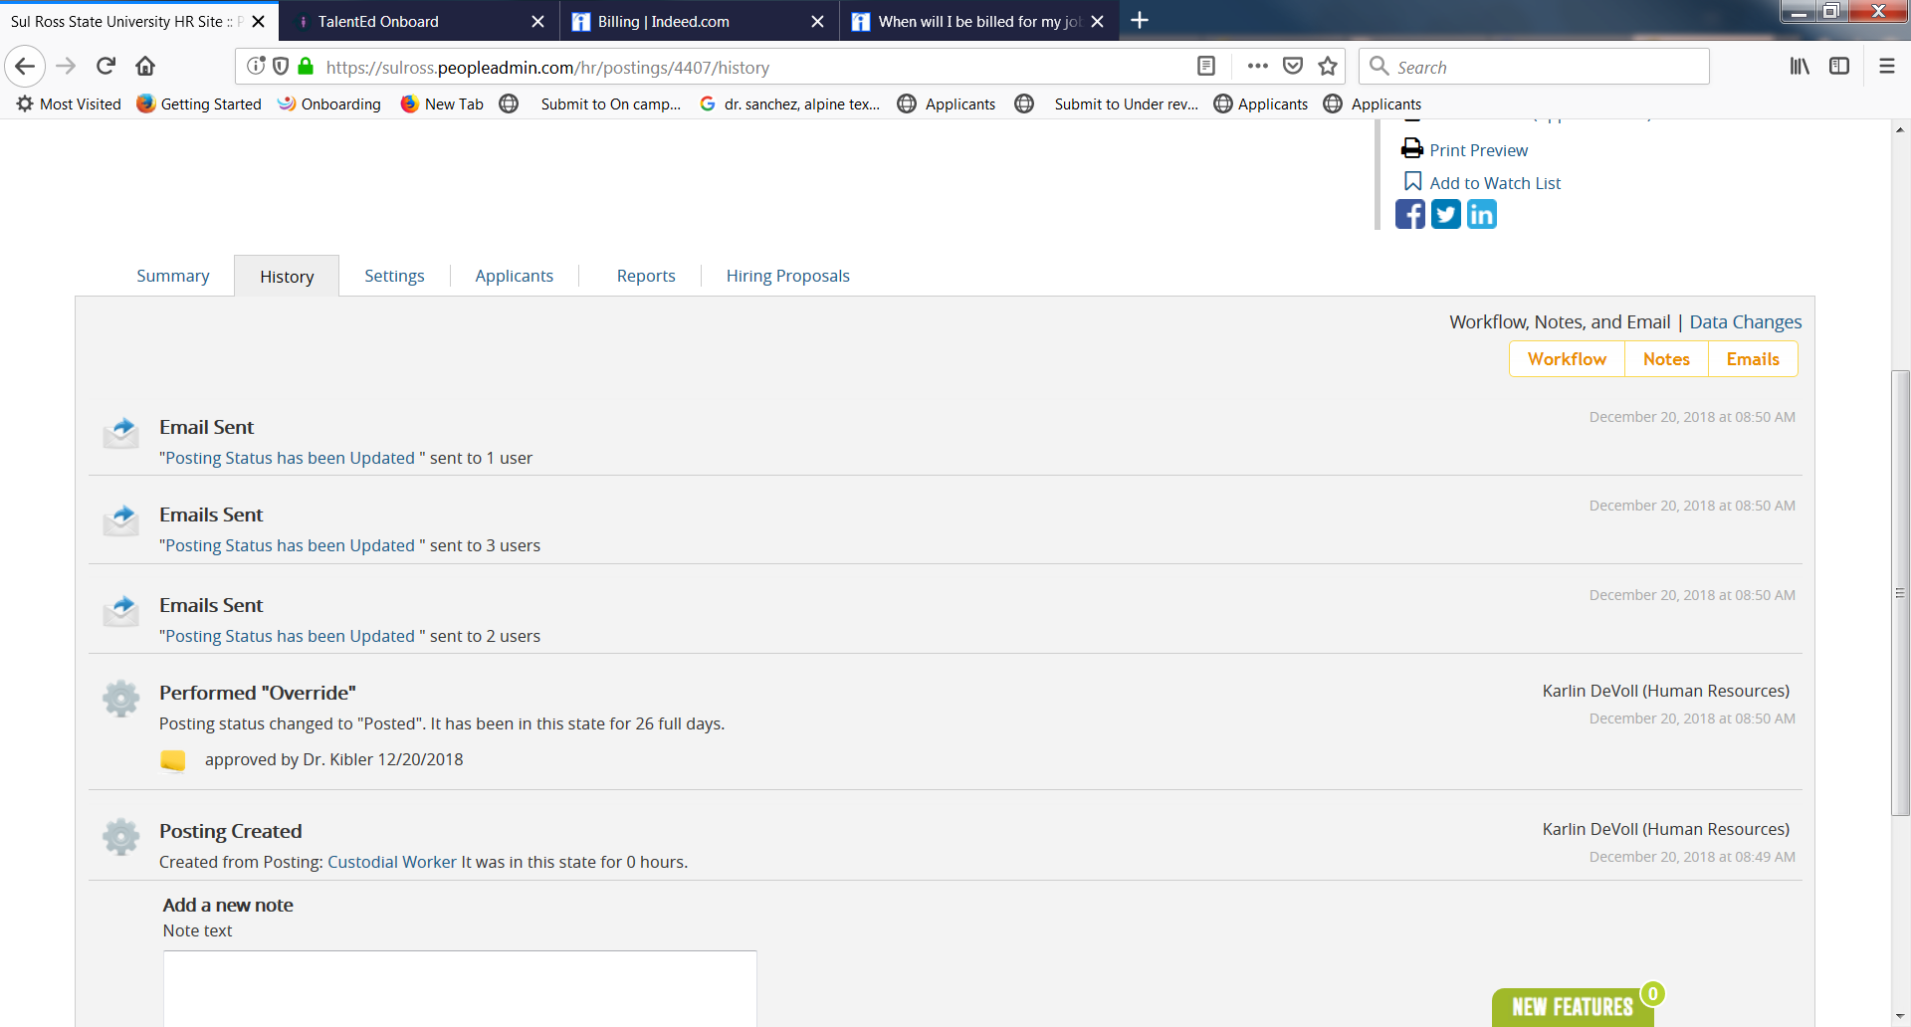
- View posting history including action taken, date, who performed the action.

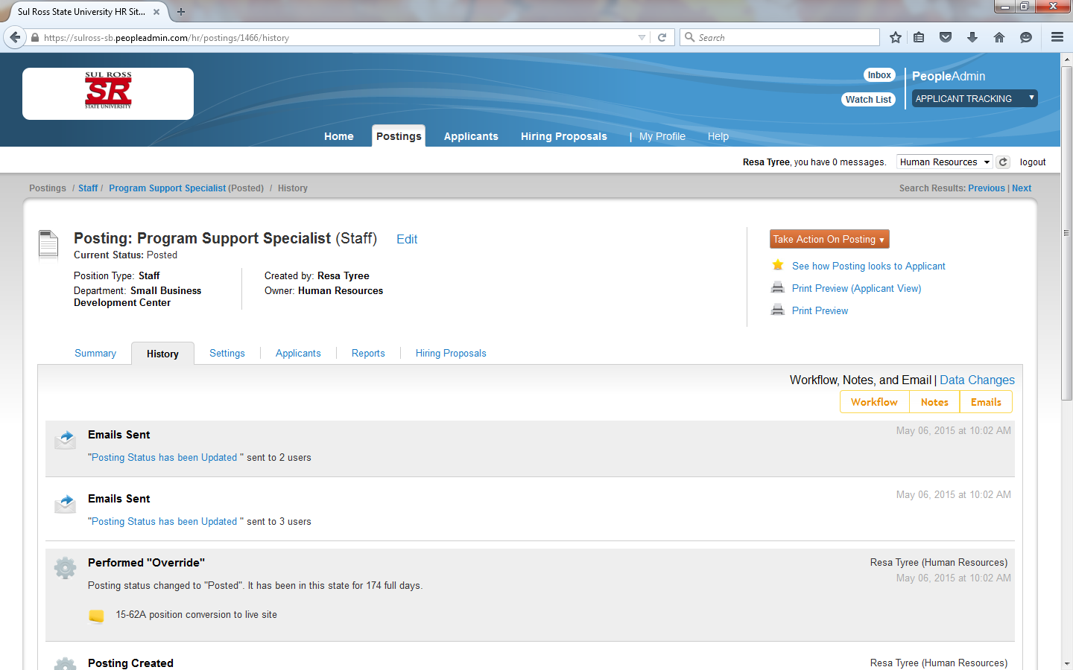

- Click APPLICANTS tab on the selected posting (see below)

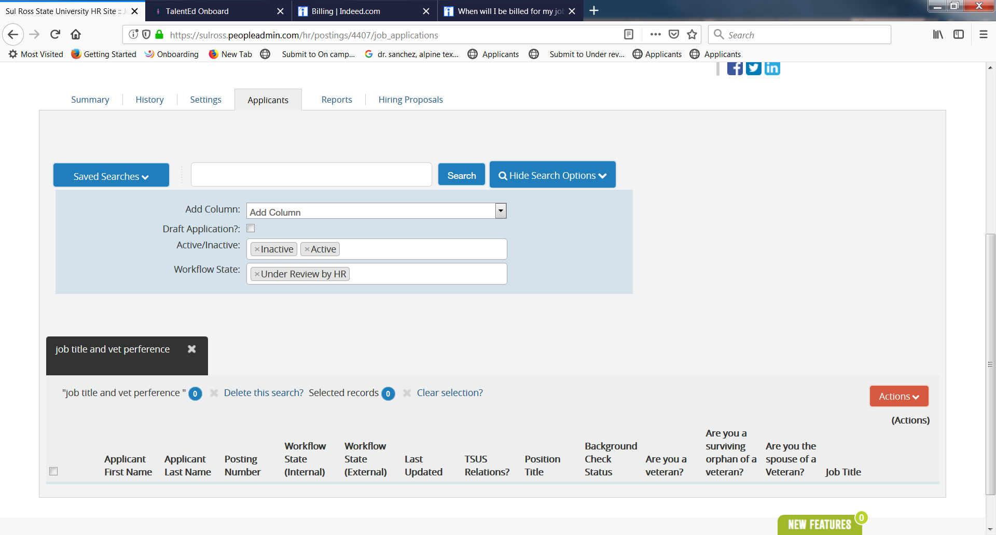

- Click the “Actions” button to access the options for the applicant group

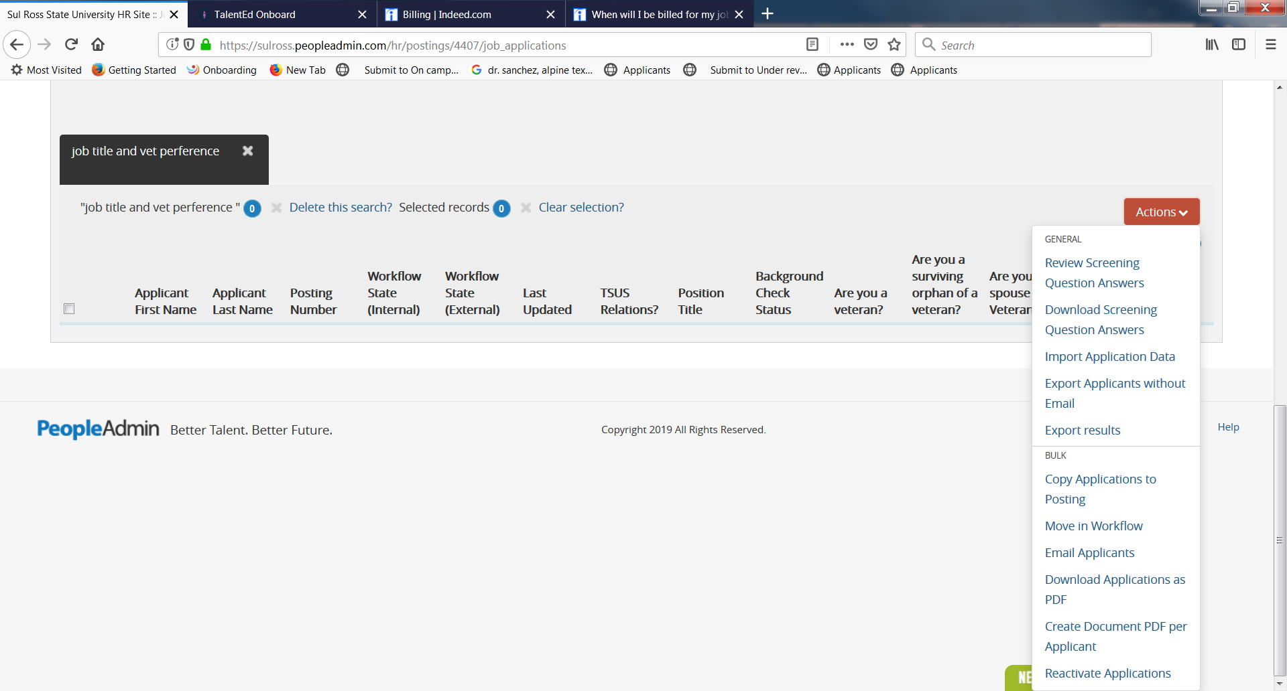

- Click “Actions” drop down list on an individual applicant to view the application.

Action button in black

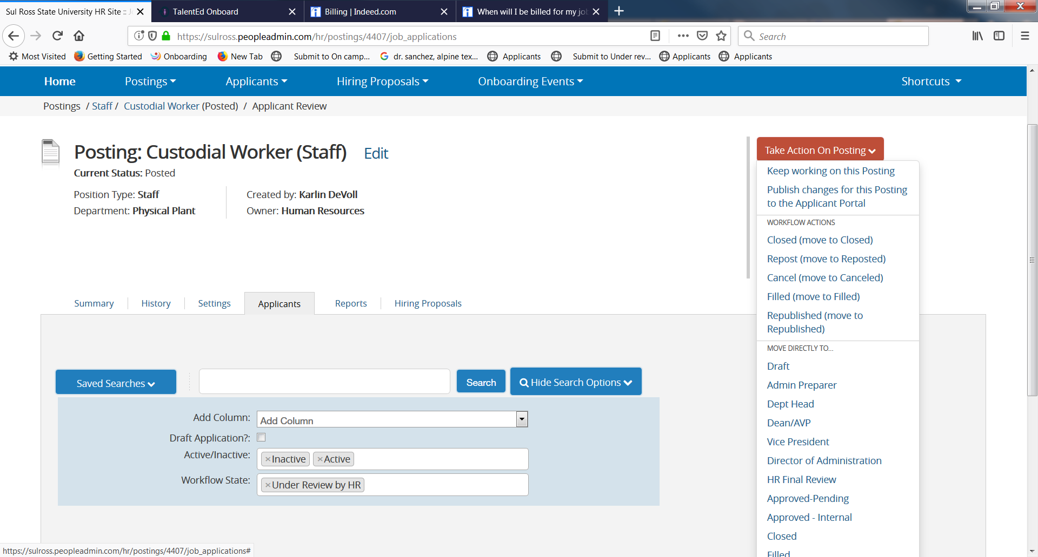

- Summary

Log in make sure you are in the Applicant Tracking module (the blue heading) to view your posting, applicants, request background checks, recommend for hire and start hiring proposal. The screen displays the posting details, internal and applicant documents, screening questions, and search committee members.
You can view the posting and review for any changes you may want to make.

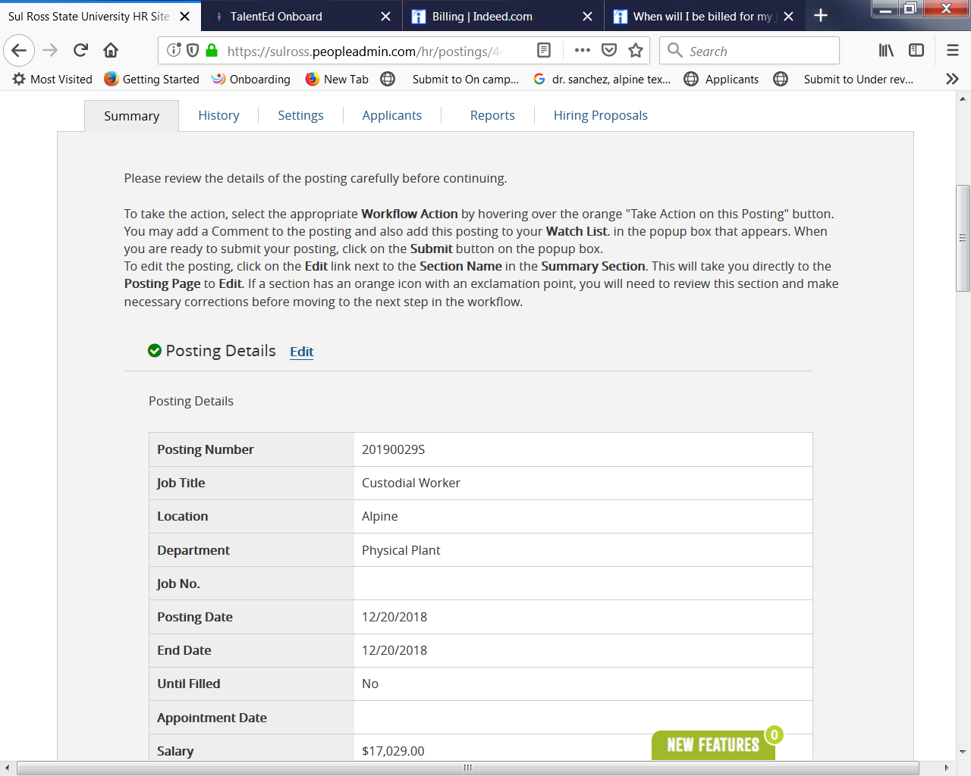

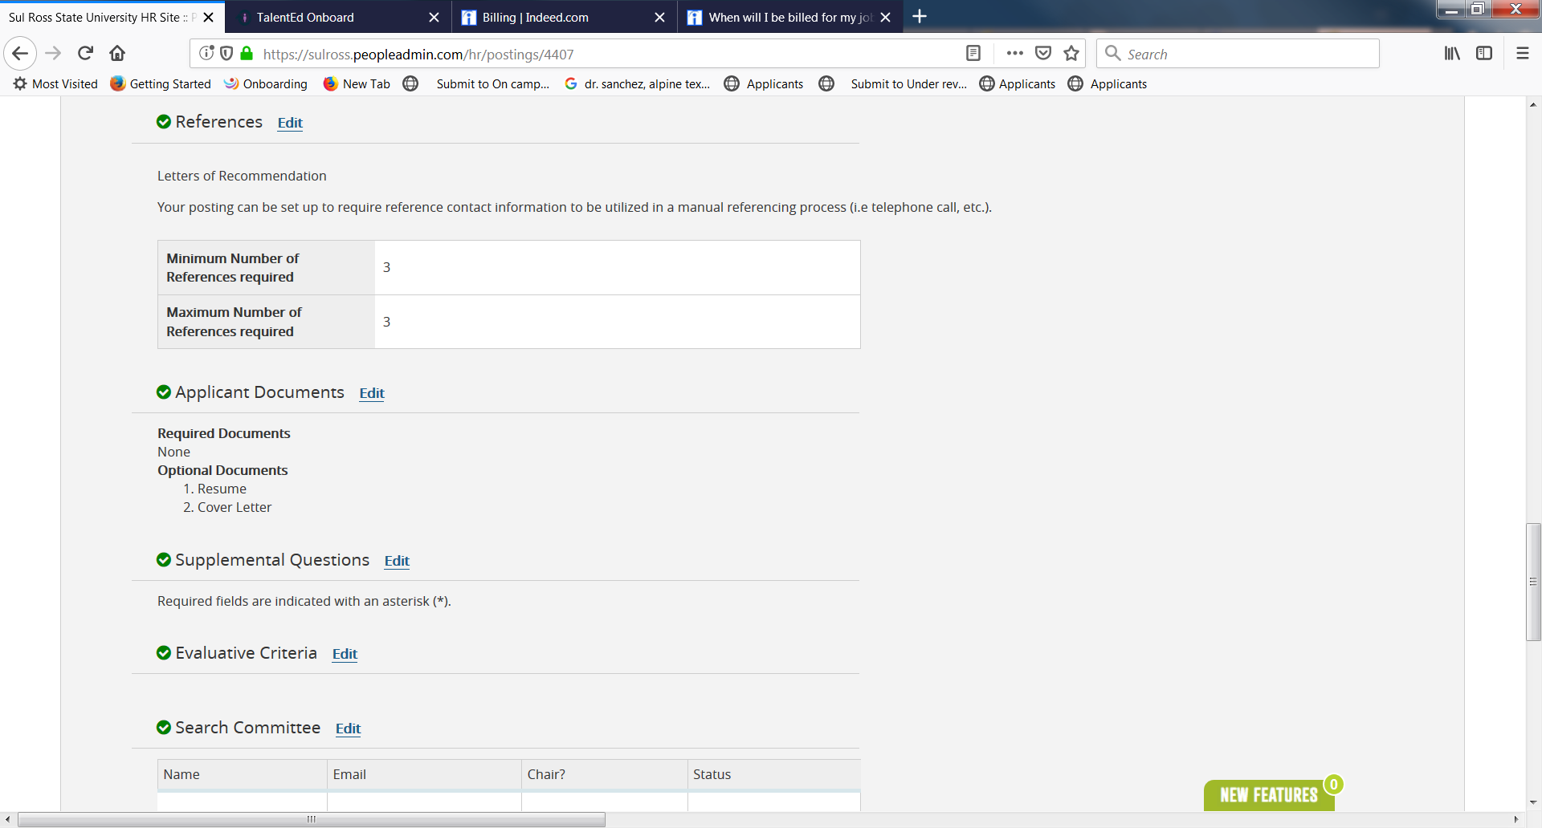

Below the Take Action On Posting orange button you can click on the links, see how posting looks to applicant

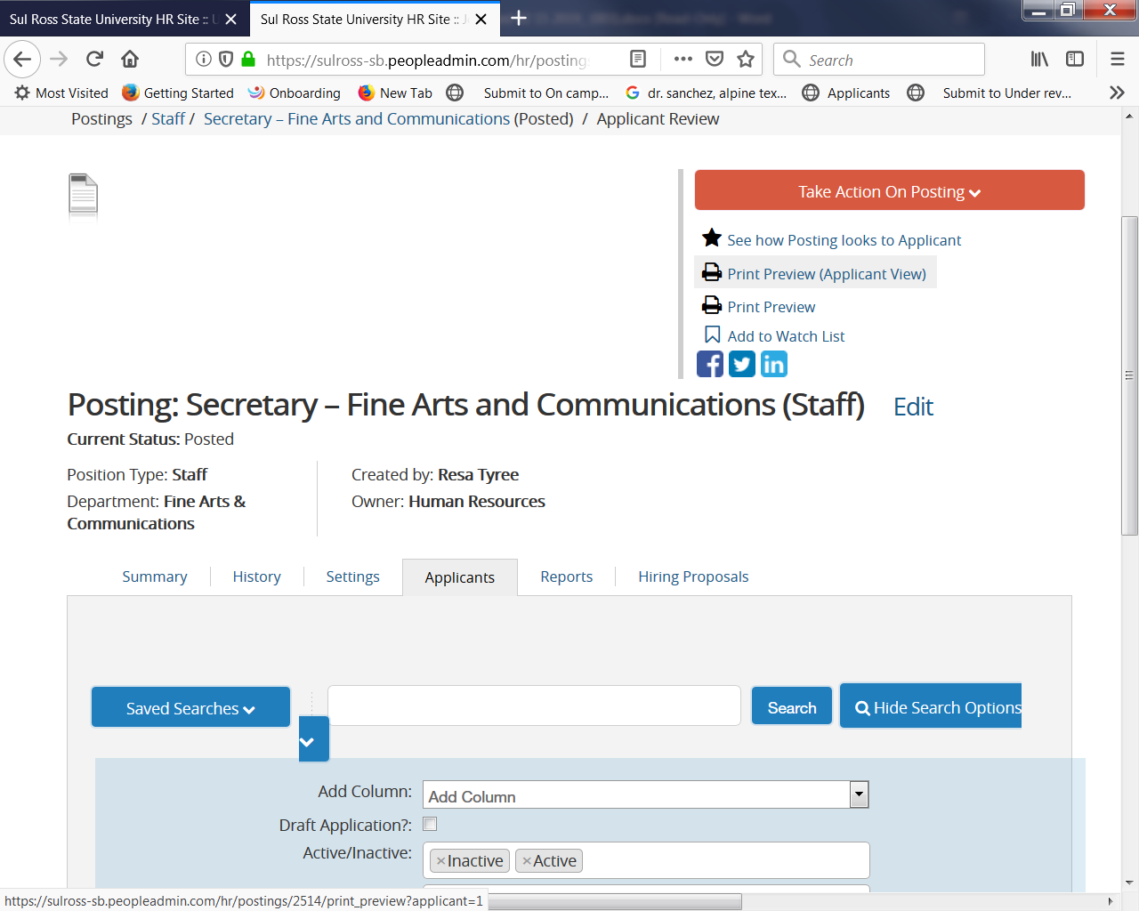

Or click on the link to print preview of the applicants view, or just print preview.

New HIRING PROCEDURES for Staff, Faculty and Temporary Monthly

- First you will want to select the applicants you want to interview and move them to “On Campus Interview”. Once you have completed the interviews and select the successful applicant, proceed with the Verification process, (contacting references etc…).
- After the verification process is complete, you will move the applicant to “Send to HR for Background Check”. This step initiates the new screening process, wherein the applicant receives an email from our background screening vendor: Choice Screening. The applicant must respond to the prompt from Choice Screening in order to move forward. (This process will result in some additional time needed to provide a thorough background check of the candidate.)

Same HIRING PROCEDURES for Student and Temporary Hourly

1. First you will want to select the applicants you want to interview and move them to “Send to HR for Background Check”. After the background check is complete HR will move to “On Campus Interview” if they are clear or ”Dispense Not Interviewed Not hired “ if they are not clear. If they are at On Campus Interview, conduct the interviews and move the successful applicant to “Recommend for Hire”, then click on the link Start Hiring Proposal and proceed to Offer Accepted.

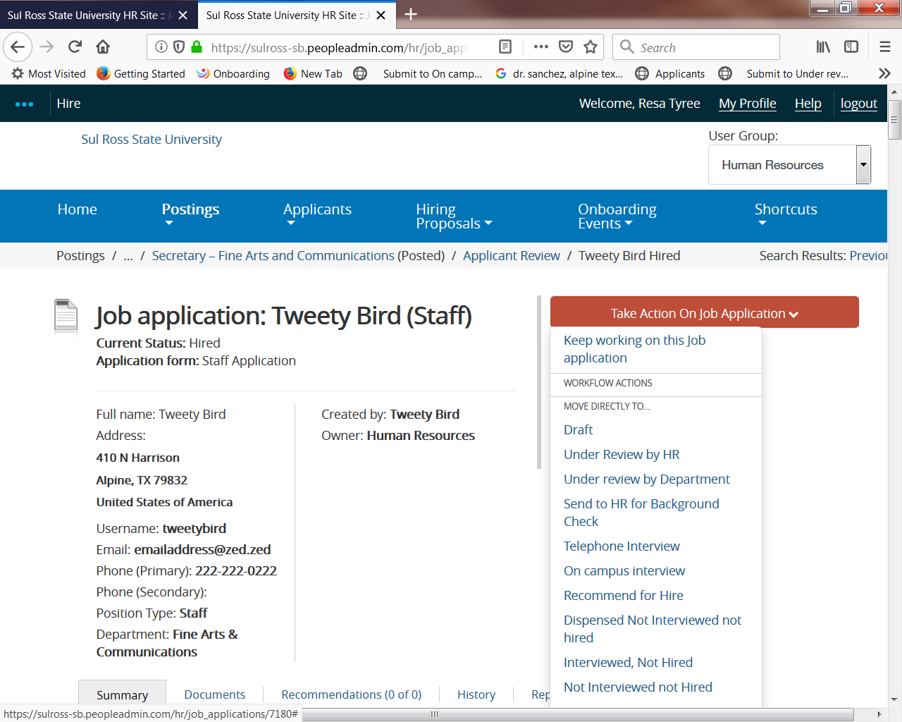

For Staff, Faculty and TM positions only, when Human Resources is notified the applicant is clear, Human Resources will move the applicant through the “Recommend for Hire”. Then the department will go to the selected applicant and see the “Start Hiring Proposal” link below the Take Action Button as seen below (Click on the link Start Hiring Proposal:

- Department heads will receive an email informing them when the applicant has been moved forward to the “Recommend for Hire, if the process appears to take longer than needed, please contact HR for updates.

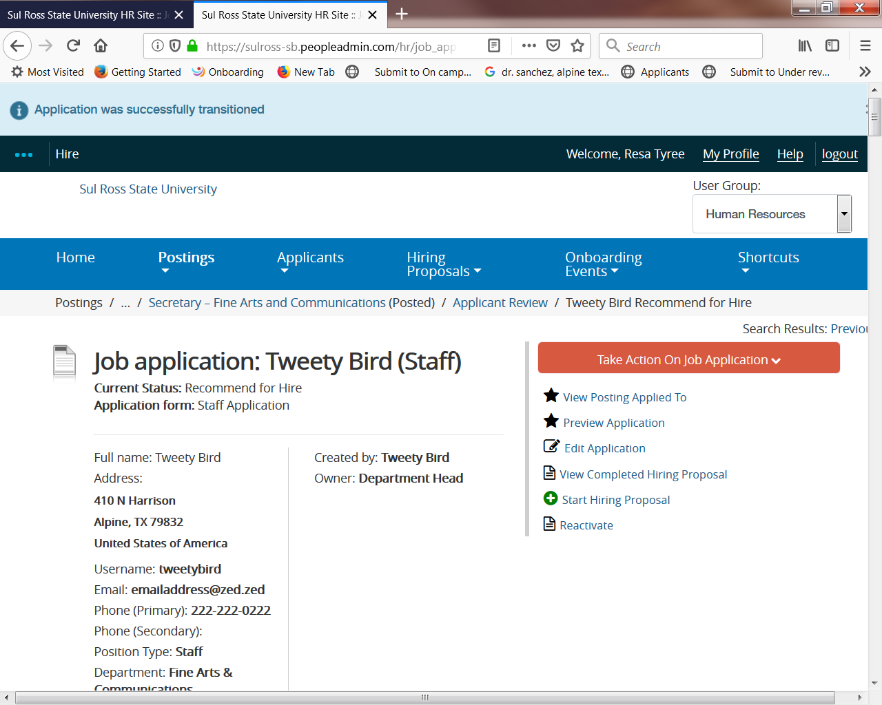

From here all applicants (Staff, Faculty, Temporary Monthly, Student and Temporary Hourly) will move through the Hiring Proposal.

Click Start Hiring Proposal button

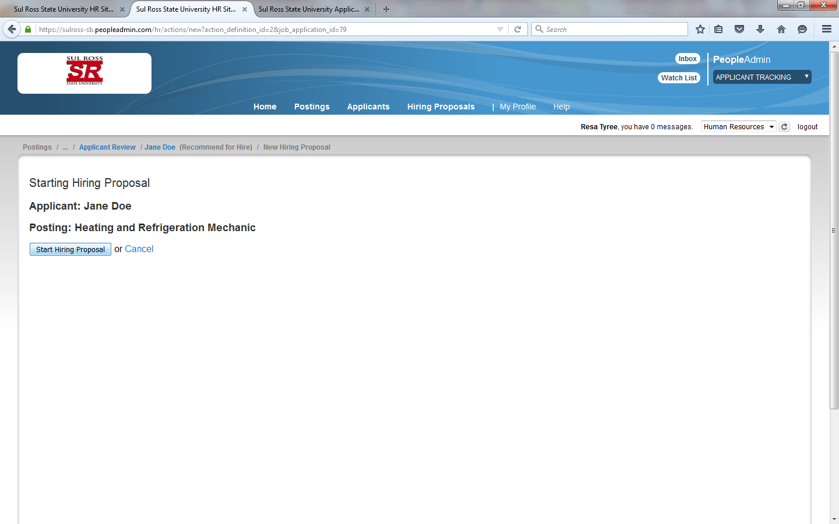

Fill in requested information:

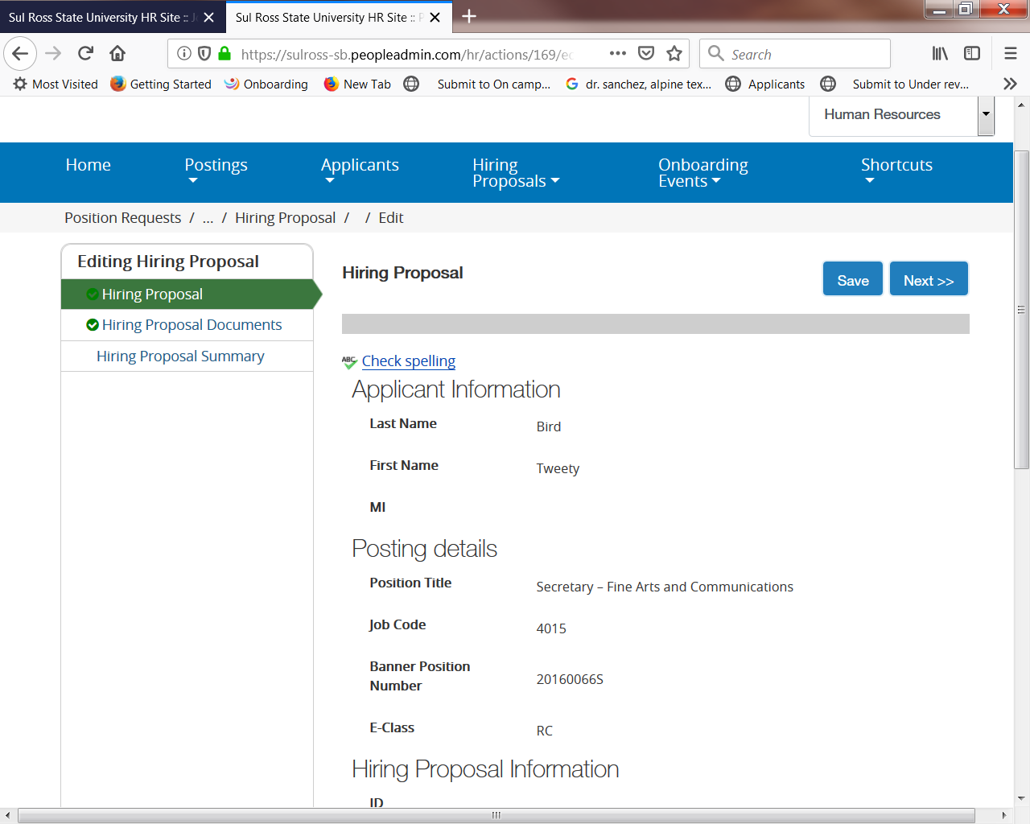

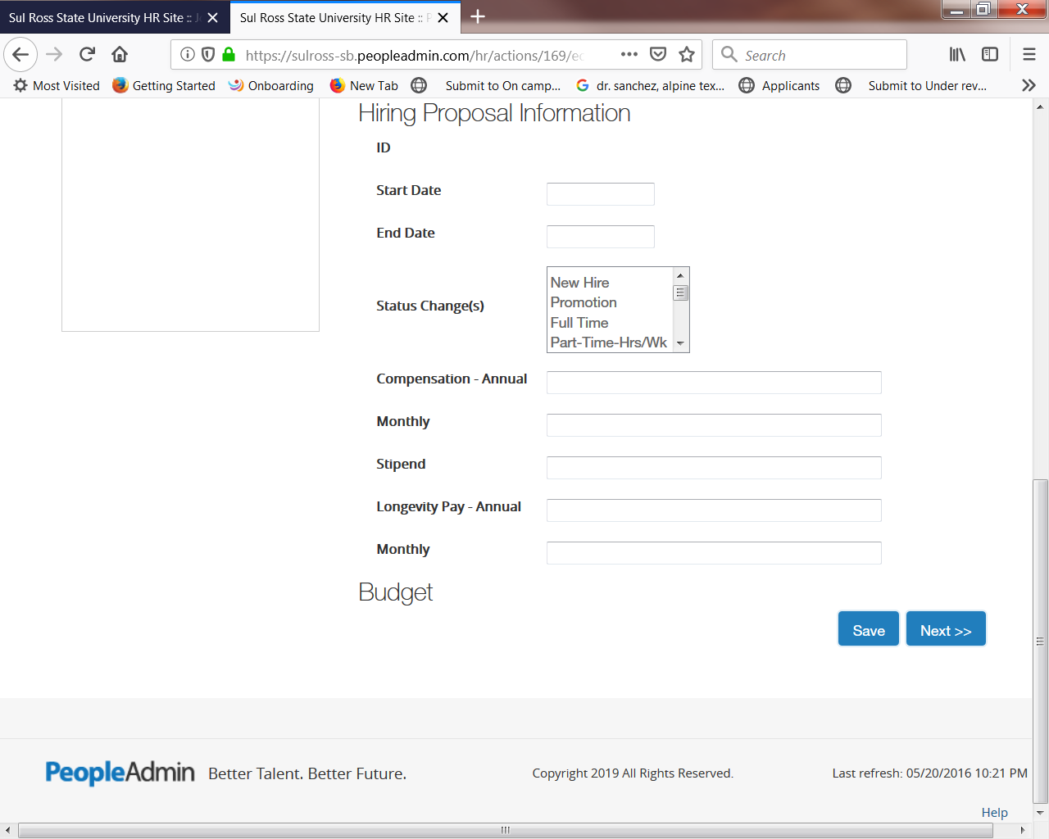

Click Next, you are on the Budget Authorization page no information needs to be entered unless you want to upload your interview documentation from this screen you would click on Actions > Upload New > Browse > and upload your documentation (which was saved to adocument file from your computer) > hit submit.

This process is optional, you can also bring the documentation to my office, or Scan and Email, or fax to me.

Click Next

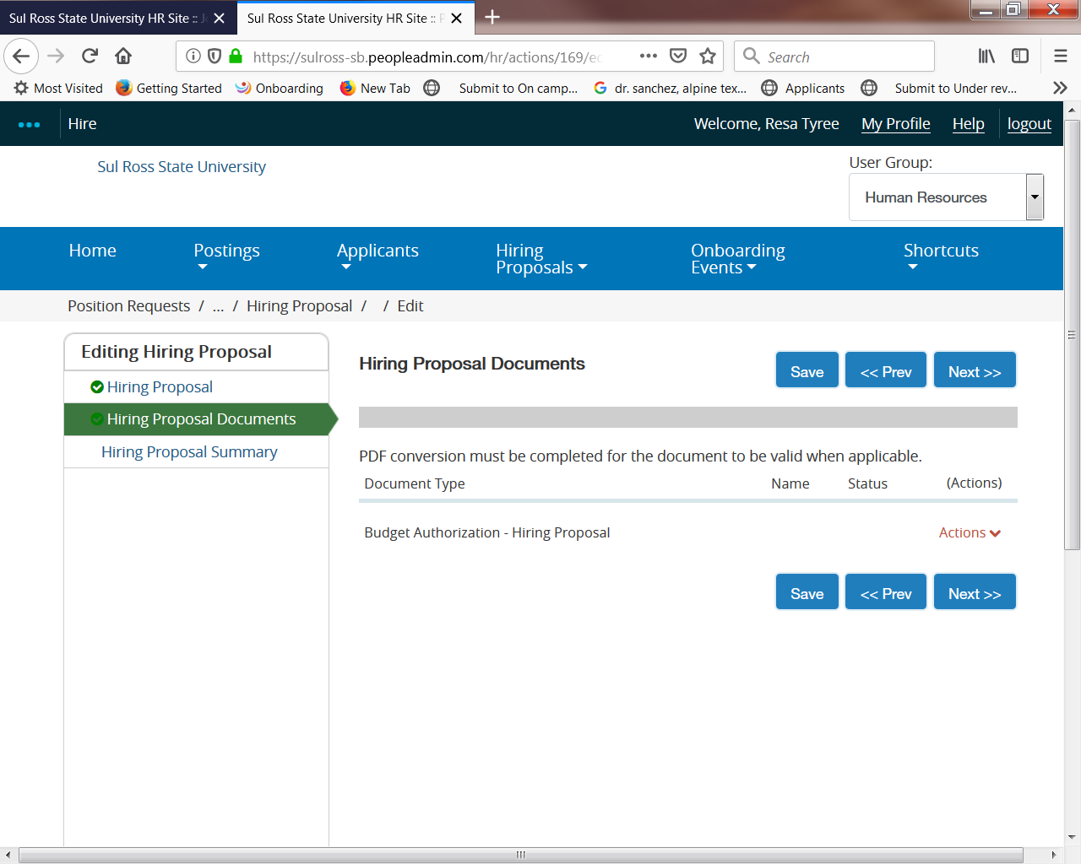

Click Next

Hover over the orange take action button and move to the next required approver (ie Dean, or Vice President for approval. Exception***Student Workers move directly to Offer Accepted, SUBMIT then STOP***:

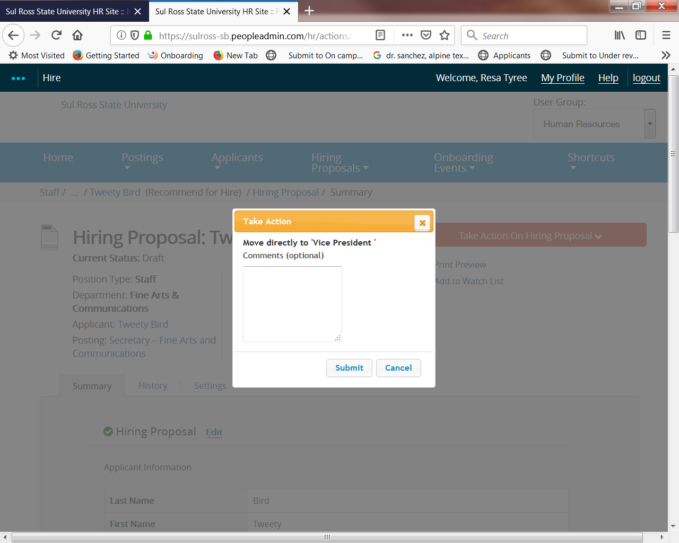

The selected applicant will now be accessed in the tab in the blue header at the top called Hiring Proposals, each person in the approval process will click on the tab “Hiring Proposals” to move the selected applicant to the next approver. The final approver,(ieVice President or President) will then move back to HR if he/she approves the selection:

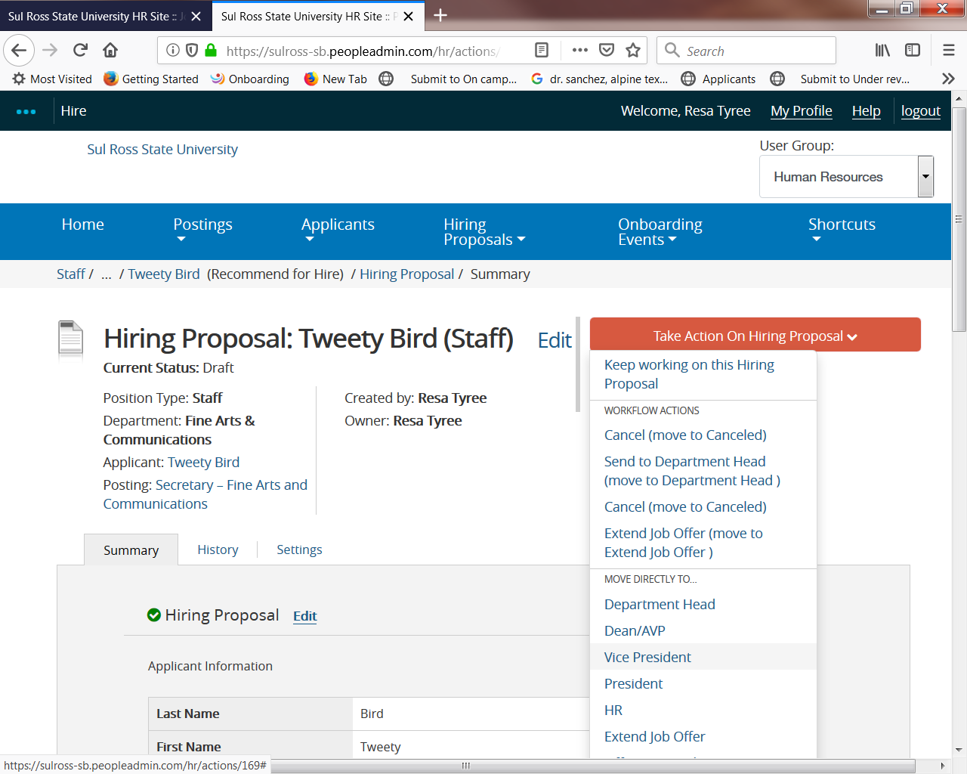

Human Resources will move the applicant to Extend Offer of Employment:

The department will then contact the applicant and offer the position.

If the applicant accepts the position, the department will move to the applicant to Offer Accepted, put in comments and hit submit, the system will move this applicant to Hired (you will NEVER move the applicant to HIRED this is automatically done once they are at offer accepted), this step is crucial for the onboarding process to begin. The onboarding process will begin by sending a link to the applicant to complete all the new hire paperwork on-line:

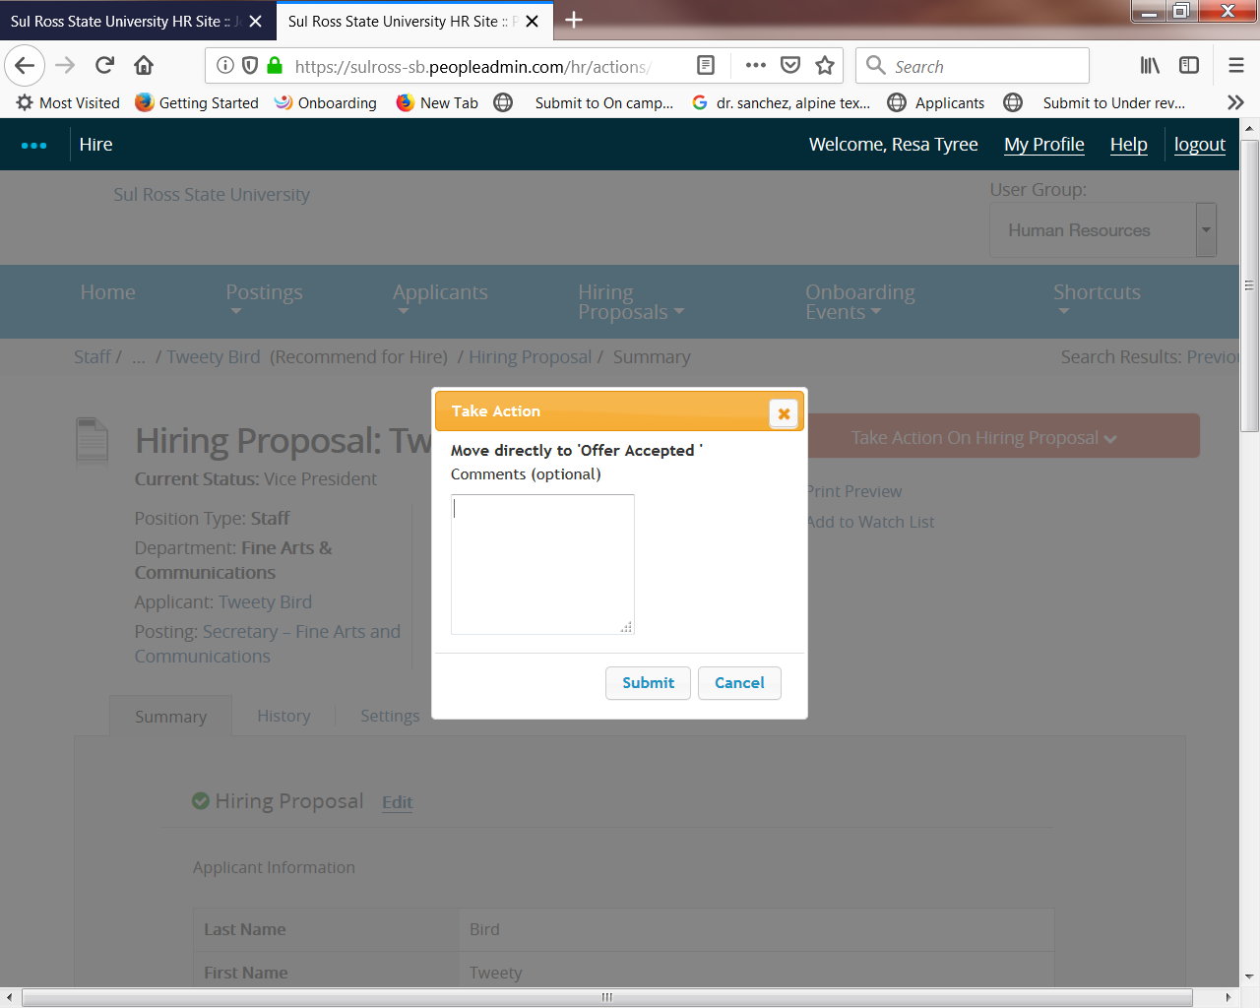

Final Step: the department will go into the position posting and move the other applicants to a final status:

For all postings, (staff, faculty and student) move each applicant to, interviewed not hired; not interviewed not hired; withdrawn etc. Once all applicants are in a final status notify Human Resources, or for student applicants notify Career Services, they will move the position to Filled, emails will be sent to each unsuccessful applicant informing them the position has been filled and remove the posting from the website.

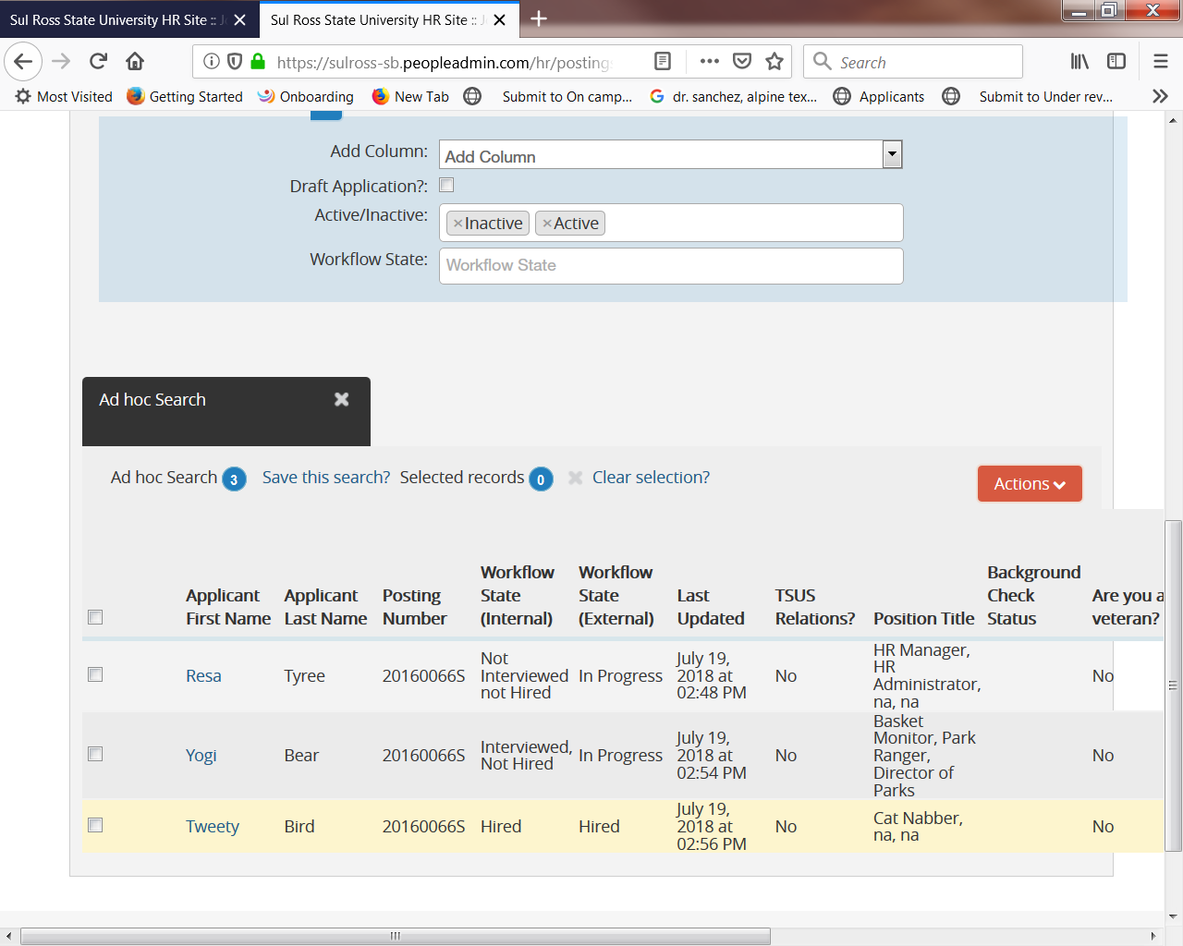

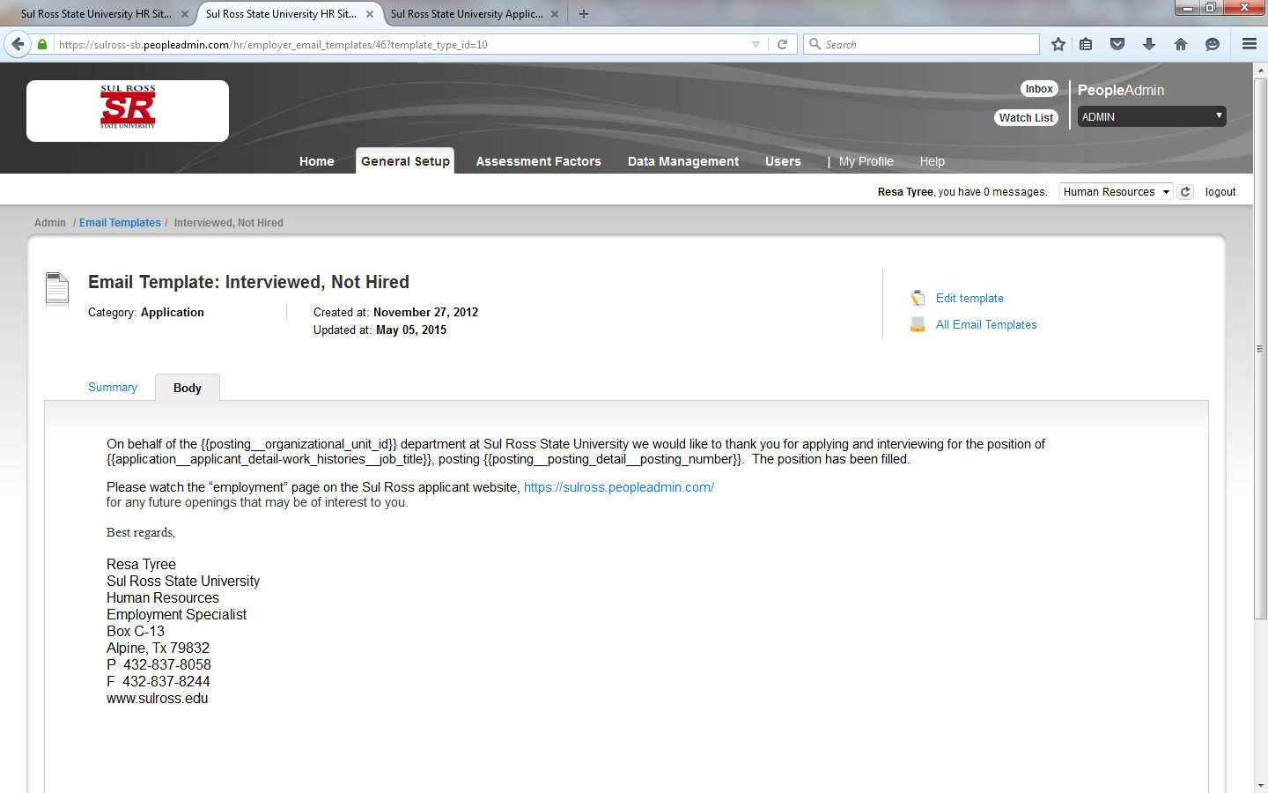

If you have any questions please contact

Human Resources
BAB #110
Alpine, Tx 79832
P 432-837-8243
F 432-837-8244

or

Career Services and Testing
Box C-171 | Room UC 211D
Alpine, TX 79832
P 432/837-8178
Fax 432/837-8724

