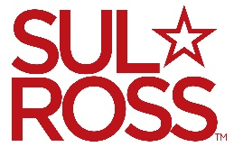 Student & Temporary Employee
Instructions on Job Applications

- Go to https://sulross.peopleadmin.com/ and create an account, you will fill out an application that is required and you can upload a resume or other documents. Most student positions only require applications.
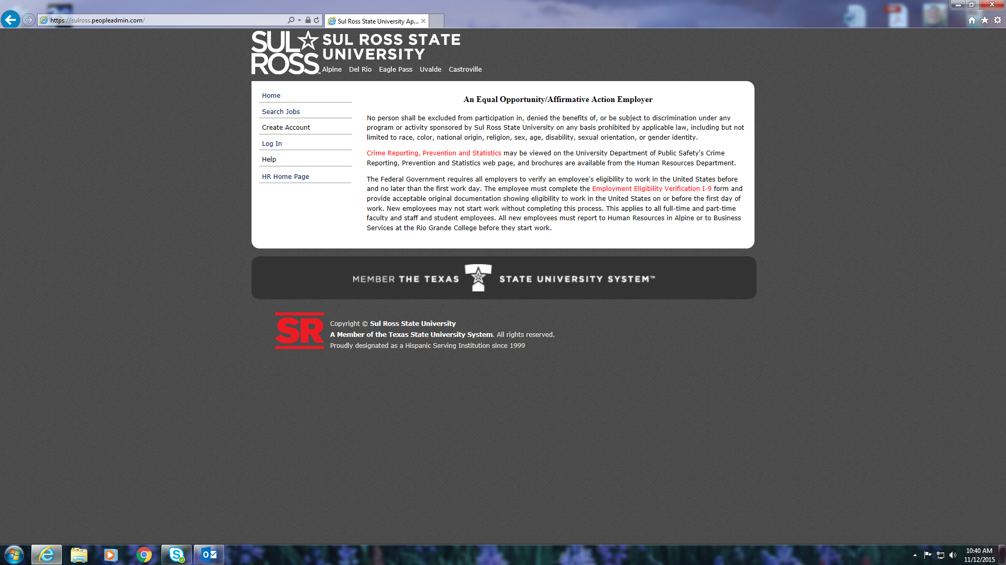
- Once you have created an account you can apply for as many jobs as you like for as long as you like. You can update your application as information changes (i.e.: address, work experience, etc.).
- On the page listed above you can click on search jobs to find positions available – on the job listings site you can narrow your search by clicking on position type or department, there are drop down menus that you can select to fine tune your search – after selecting you will click on the search button and it will display the job listings.
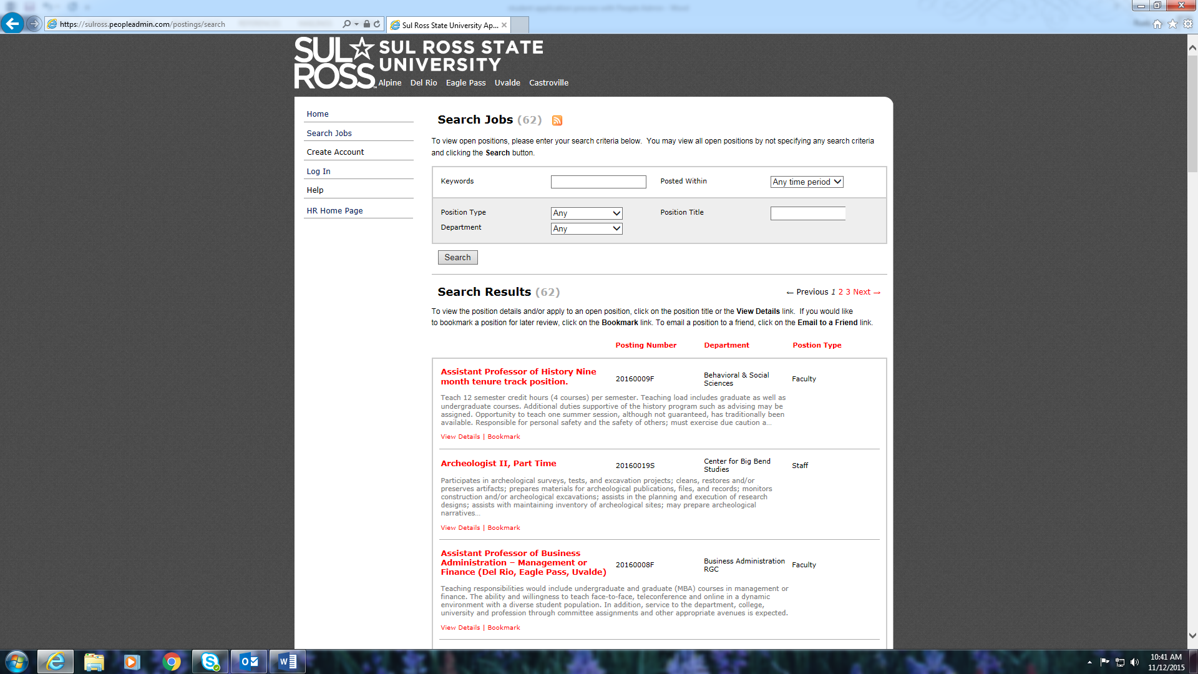
- Once you find job listings you are interested in you will click on the job title and it will give you more information about the position – on this page at the top you can click on “apply for this job”
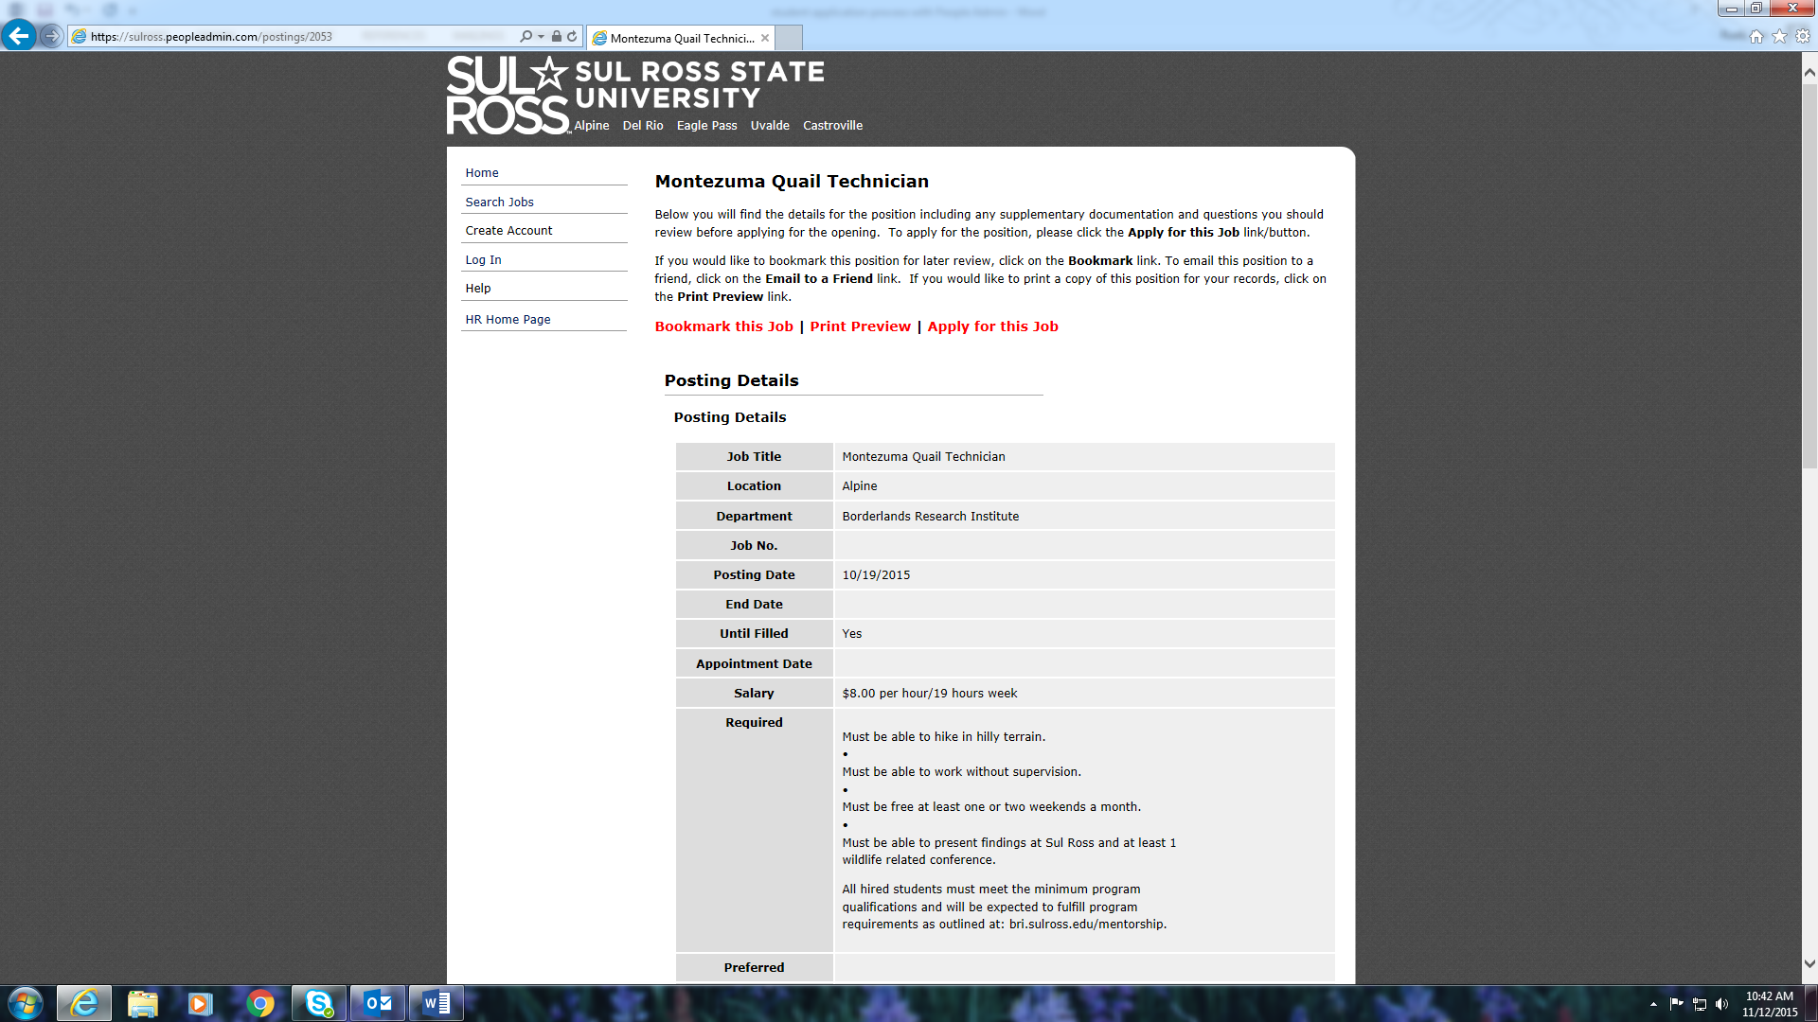
- After clicking on “apply for this job” it will ask you to go to the account you have created. From your account you apply for the job and your application is uploaded and sent to the department that is hiring.
- The system is designed that you will receive an email letting you know when a position has been filled.
- It is always good to physically go to the department that has a job you are interested in and introduce yourself. Face to face contact with a potential employee on campus can make a crucial connection that can potentially help land the job. It gives you the opportunity to sell yourself.

